**Robot Tracking and distance location using Raspberry Pi cameras**

The objective from this paper is to demonstrate and explain the method that has been used to track a Robot in an 18’ by 18’ field using a Raspberry Pi camera and a bunch of image processing tools that are easy to utilize in python environment.

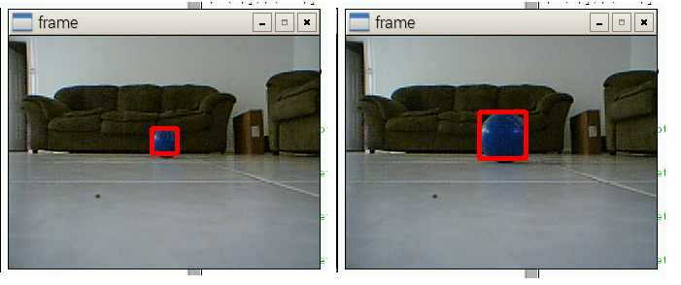A color identification method is used where, for example, a blue-colored-object is attached on the top of the robot, and a USB Playstation eye camera (has a better depth of field, and resolution than the original pi’s camera) is used to capture a real time video streaming where the object is identified by setting an upper and lower limits to the blue color that we want to isolate and identify in our captured frame. The proposed Raspberry Pi code will isolate the object, contour the object, blur everything else and will draw a red square on our desired object. The square that is drawn will be utilized to estimate the distance from the camera to the object.

Two screen shots that depict the changing of the drawn square around the object as it gets further and further from the camera   
fundamentally, the square size changes when the object change its distance from the camera, and this variation has been utilized to extract the following polynomial that gives the approximate distance (based on this selected object) with one side of the drawn square around the object. The formula is obtained by Excel curve fitting where multiple points is entered to deduce the distance equation.

The equation $y=1804.1x^{-.1.145}$ is used estimate the distance from the object to the pi’s camera

Since the scope of the actual project is implementing 4 Raspberry pis on each corner of the 18’ by 18’ inch field, a triangulation method needs to be done to find the exact position of the robot with that field. To utilize the triangulation successfully the veering angle of the robot from a reference point need to be measured also and the combination of the distance and angle will be sent to one Raspberry pi server to implement the triangulation to find the actual position of the robot within that field.